**ASSIGNMENT-1**

|  |  |
| --- | --- |
| **Assignment Date** | 19 September 2022 |
| **Student Name** | MOHAMMED HALITH |
| **Student Roll Number** | 19EC160 |
| **Maximum Marks** | 2 Marks |

**QUESTION 1:**

# Create a user registration page form with following field Name:

**SOLUTION:**

<!DOCTYPE html>

<html lang="en">

<head>

<meta charset="UTF-8">

<meta http-equiv="X-UA-Compatible" content="IE=edge">

<meta name="viewport" content="width=device-width,initial-scale=1.0">

<title>Registration Form</title>

</head>

<body>

<p>

<h1>REGISTRATION</h1>

</p>

<b><b>

<form>

NAME: <input type=Text"><br><br> EMAIL: <input type=Text"><br><br>

MOBILE: <input type=Text"><br><br> CITY: <input type=Text"><br><br> STATE: <input type=Text"><br><br> COUNTRY: <input type=Text"><br><br>

</form>

</body>

</html>

**OUTPUT:**

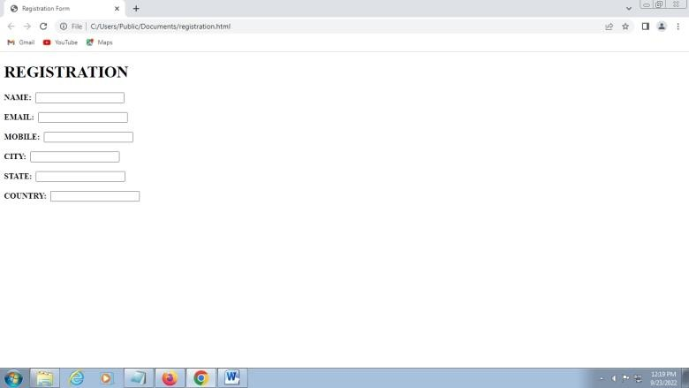

# QUESTION 2

**Execute the HTML Formating Elements**

Solution:

<html>

<body>

<b>Apple</b>

<Strong>Ball</Strong>

<i>Dog</i>

<em>Egg</em>

<mark>Fish</mark>

<Small>Goat</Small>

<del>Hen</del>

<ins>Ink</ins>

<sub>Jackfruit</sub>

<sup>King</sup>

</body>

</html>

**OUTPUT**:

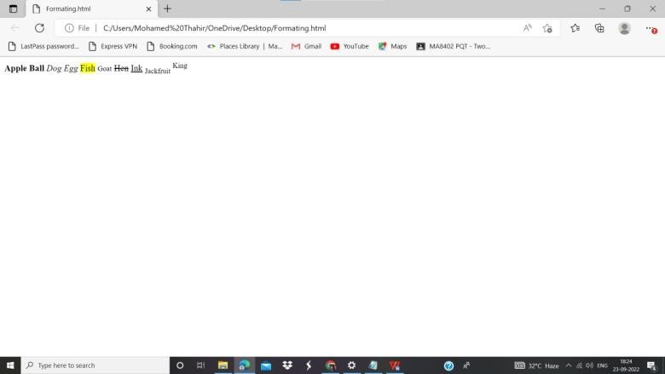

**Question 3**

**Find out all other HTML Input Types:**

**Solution:**

* <input type="button">
* <input type="checkbox">
* <input type="color">
* <input type="date">
* <input type="datetime-local">
* <input type="email">
* <input type="file">
* <input type="hidden">
* <input type="image">
* <input type="month">
* <input type="number">
* <input type="password">
* <input type="radio">
* <input type="range">
* <input type="reset">
* <input type="search">
* <input type="submit">
* <input type="tel">
* <input type="text">
* <input type="time">
* <input type="url">
* <input type="week">

**OUTPUT:**

